**Mockito Hands-On Exercises**

**Exercise 1: Mocking and Stubbing**

Scenario: You need to test a service that depends on an external API. Use Mockito to mock the external API and stub its methods.

**ExternalAPI.java :**

package com.example;

public interface ExternalAPI {

String getData();

}

**MyService.java :**

package com.example;

public class MyService {

private ExternalAPI externalApi;

public MyService(ExternalAPI externalApi) {

this.externalApi = externalApi;

}

public String fetchData() {

return externalApi.getData();

}

}

**MyServiceTest.java :**

package com.example;

import static org.junit.jupiter.api.Assertions.assertEquals;

import static org.mockito.Mockito.*;

import org.junit.jupiter.api.Test;

import org.mockito.Mockito;

public class MyServiceTest {

@Test

public void testExternalApi() {

ExternalAPI mockApi = Mockito.mock(ExternalAPI.class);

when(mockApi.getData()).thenReturn("Mock Data");

MyService service = new MyService(mockApi);

String result = service.fetchData();

assertEquals("Mock Data", result);

}

}

**Output :**

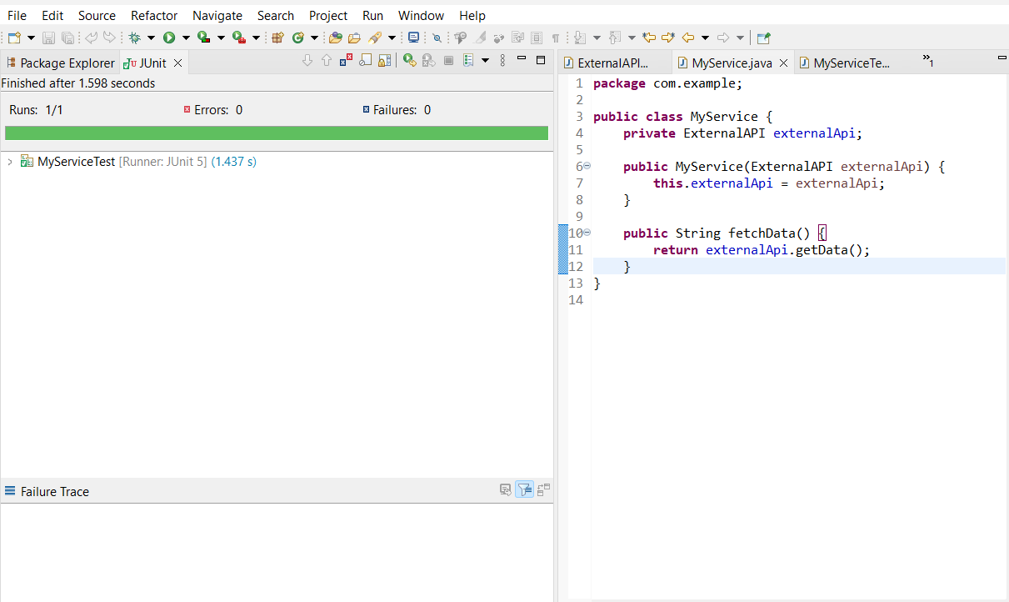

**Exercise 2: Verifying Interactions**

**Scenario:**

You need to ensure that a method is called with specific arguments.

**ExternalAPI.java :**

package com.example;

public interface ExternalApi {

String getData();

}

**MyService.java :**

package com.example;

public class MyService {

private ExternalApi externalApi;

public MyService(ExternalApi externalApi) {

this.externalApi = externalApi;

}

public String fetchData() {

return externalApi.getData();

}

}

**MyServiceTest.java :**

package com.example;

import static org.mockito.Mockito.*;

import org.junit.jupiter.api.Test;

import org.mockito.Mockito;

public class MyServiceTest {

@Test

public void testVerifyInteraction() {

ExternalApi mockApi = Mockito.mock(ExternalApi.class);

MyService service = new MyService(mockApi);

service.fetchData();

verify(mockApi).getData();

}

}

**Output :**

